# O B J E C T O R I E N T E D V I S U A L P R O G R A M M I N G

# R E P O R T



# CREATE BY:

1. **Ida Ayu Wayan Pradnya**
2. **Melinia Fransiska Telaumbanua**
3. **Misha Andalusia**

**CLASS INFORMATION TECHNOLOGY 2 INFORMATION TECHNOLOGY STUDY PROGRAM FACULTY OF COMPUTING**

**1.LOGIN PAGE - LIBRARY MANAGEMENT SYSTEM**

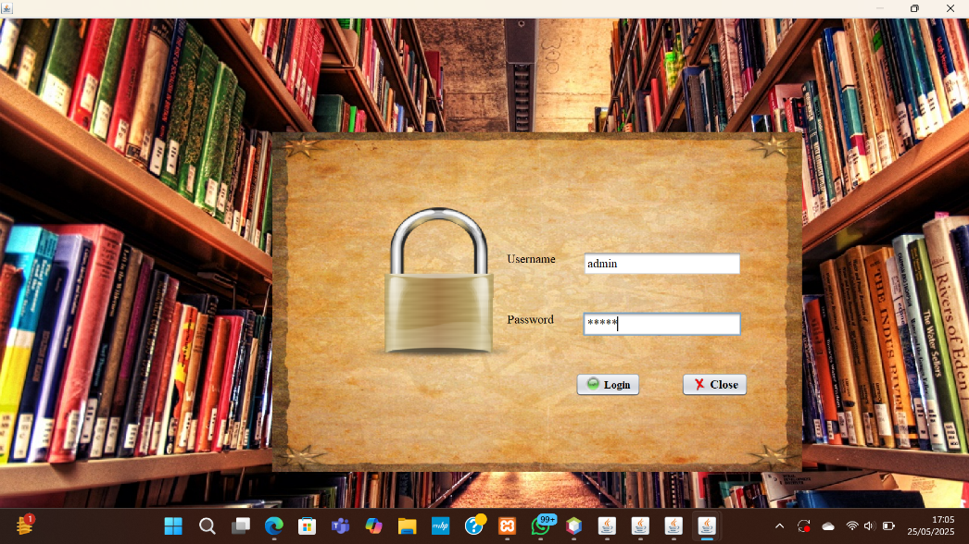

The **Login Page** is the initial interface that users must access before entering the system. On this page, users are required to enter their registered **Username** and **Password**.

There are two available buttons:

* **Login**: to verify the account and proceed into the system.
* **Close**: to exit the application.

The interface is designed with a **background image of library bookshelves** and a **padlock icon** placed at the center as a symbol of system security.

**2. MAIN MENU - LIBRARY MANAGEMENT SYSTEM**



This is the **Main Menu page** that appears after the user successfully logs in to the system. The page provides access to various features of the Library Management System through several buttons displayed at the top of the interface. Each button is equipped with an icon and a label for clarity.

The available menu options are:

* **New Student**: to add new student data into the system.
* **New Book**: to add new book records to the library database.
* **Statistics**: to view data summaries and activity reports within the system.
* **Issue Book**: to record book borrowing transactions.
* **Return Book**: to process book return transactions.
* **Logout**: to exit from the system and return to the login page.

The interface uses a **background image of library bookshelves**, creating a visual theme that aligns with the system's purpose.

**3. ISSUE BOOK – LIBRARY MANAGEMENT SYSTEM**

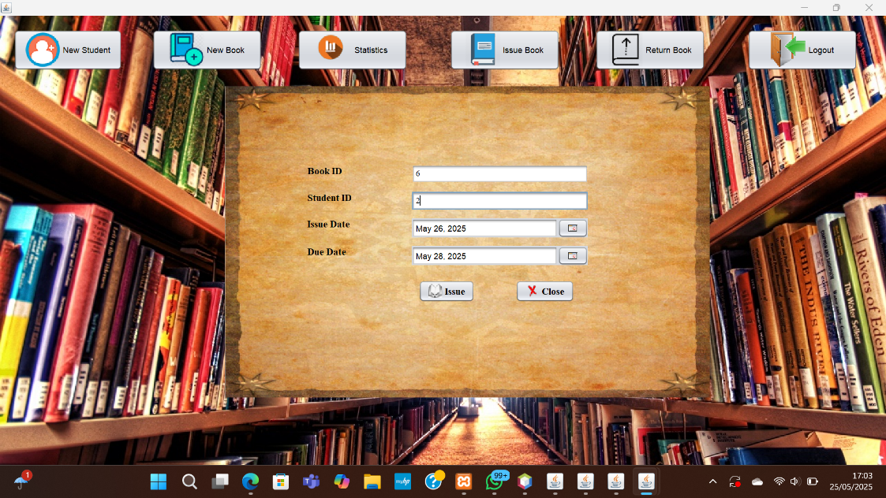

This is the **Issue Book** page where the librarian can record book borrowing by students. The page provides several input fields:

* **Book ID**: The unique identifier for the book being borrowed.
* **Student ID**: The unique identifier of the student borrowing the book.
* **Issue Date**: The date when the book is borrowed.
* **Due Date**: The date by which the book must be returned.

Once the information is entered, clicking the **Issue** button will process and save the borrowing data into the system database.

At the top, the page still displays the main navigation buttons for easy access to other functions such as **New Student**, **New Book**, **Statistics**, **Return Book**, and **Logout**.

The interface uses a consistent **library bookshelf background** and parchment-style form layout to maintain a visual theme aligned with the library environment.

**4. NEW STUDENT – LIBRARY MANAGEMENT SYSTEM**

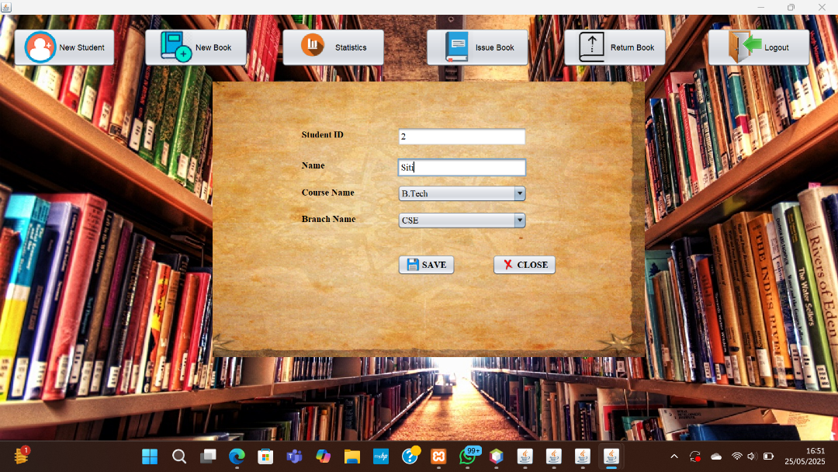

This is the **New Student** page where the librarian can register new students into the system. The page provides the following input fields:

* **Student ID**: Unique identifier for each student.
* **Name**: Full name of the student.
* **Course Name**: The program the student is enrolled in.
* **Branch Name**: The student's department or major.

After filling in the data, the librarian can click **SAVE** to store the information into the system database.

The page maintains the same **library bookshelf background theme** for consistency across the application interface.

**5.BOOK ENTRY – LIBRARY MANAGEMENT SYSTEM**

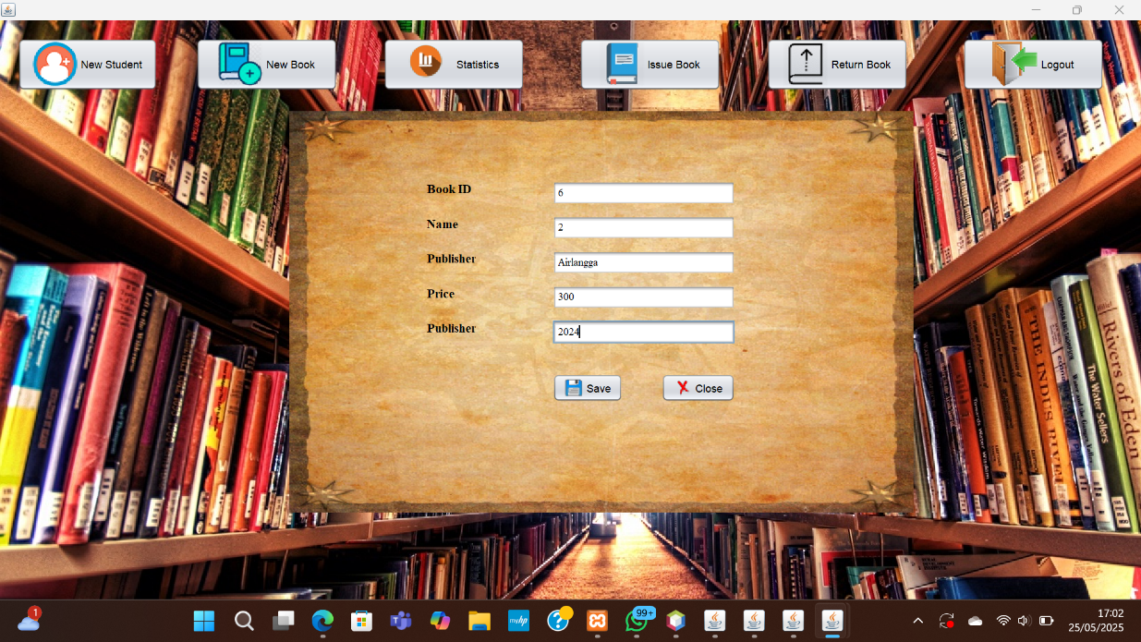

This feature is part of the Library Management System, designed to add new book records into the system. It allows the admin to input and manage book data efficiently.

Key Points:

* Used to input new book details.

Fields include:

* Book ID
* Book Name
* Publisher
* Price
* Publishing Year
* Provides Save and Close buttons for data handling.
* Supports efficient and organized book inventory management.

**6.BOOK RETURN – LIBRARY MANAGEMENT SYSTEM**

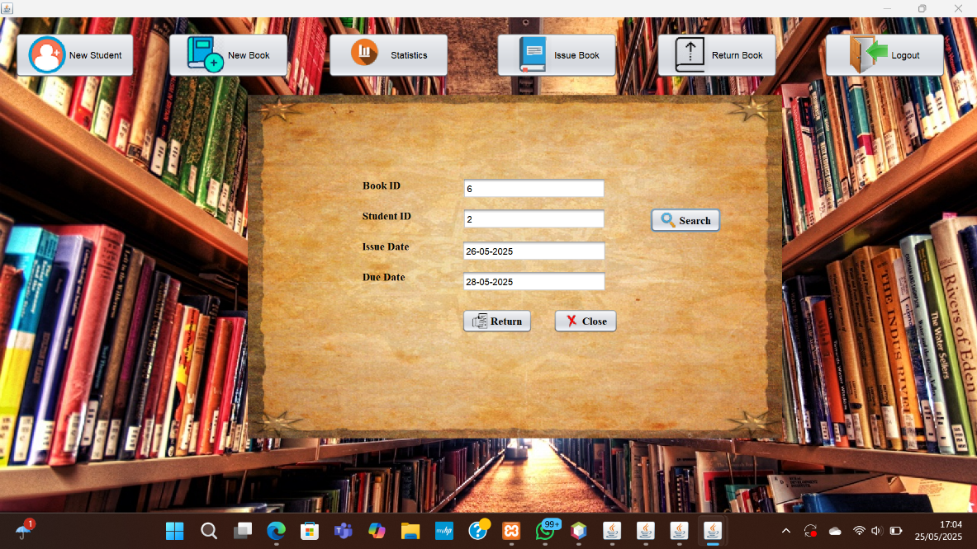

This is **the Return Book page**, where the librarian processes the return of borrowed books. The interface allows the librarian to retrieve and confirm borrowing details before finalizing the return.

Input Fields:

* Book ID: Unique identifier of the book being returned.
* Student ID: Unique identifier of the student who borrowed the book.
* Issue Date: The date the book was originally issued (auto-filled).
* Due Date: The deadline for returning the book (auto-filled).
* Return Date: The actual return date.

After entering the Book ID and Student ID, the librarian can click Search to retrieve the record. Clicking Return completes the return process.

Available Buttons:

* Search – Finds the book issue record.
* Return – Confirms the return transaction.
* Close – Exits the page.

The page maintains a library bookshelf background and parchment-style form, ensuring a consistent and thematic visual design across the system.